**School of Electrical**

**and Electronic Engineering**



**Robot Orchestra**

**Final Report**

**Group 11**

|  |  |  |
| --- | --- | --- |
| Group Members: | Buruiana, Andrei | 9478411 |
|  | Chanda, Joyanto | 9015629 |
|  | Dimou, Theodoros | 9126435 |
|  | Fumagalli, Francesco | 9017237 |
|  | Petrovs, Antons | 9474345 |
|  | Simpson, Joshua | 8929879 |

Tutors: Prof. Danielle George and Dr. William McGenn

Date: 15 May 2018

Table of Contents

1. Heading 1 3

1.1. Heading 2 3

1.1.1. Heading 3 3

1.1.2. Bullet points 3

2. References 4

# Xylophone

The xylophone was chosen to demonstrate the workings of a full electronic system.

To meet the aims of the project, the xylophone needs to meet the following specification:

* play the tracks chosen for the xylophone
  + design and manufacture PCBs to power solenoids
  + design and build a stand to hold the Solenoids and PCBs
  + write software for the MyRio microcontroller to control the instrument
  + integrate the software with the hardware
  + when each key is hit it must produce the corresponding note
* communicate with the conductor so it can be controlled alongside the other instruments (objective 4)
  + write software so it can be controlled with the conductor
  + integrate the Wifi module with the MyRio
  + integrate the conductor with the instrument
* be transportable (objective 3)
  + design the hardware so it can be dismantled for transport.

It is made up of two systems one uses a National Instruments MyRio that takes the sequence of notes to be played and actuates the solenoids to hit the keys; the second system also using a MyRio uses piezo electric sensors to monitor if any keys are hit. The MyRio then outputs the respective note through an amplifier to a speaker. The xylophone is made from clear Perspex so all the circuitry and processors are clearly displayed. As shown in Figure 1.1. The xylophone has a traditional shape with 12 keys. The keys are to be hit by solenoids these are held above the keys using a Bosch bar supported by two threaded rods. The xylophone can be disassembled so it can be transported easily. The Bosch bar can be removed, the keys can be taken off and the two sides of the xylophone can be taken apart. This will allow it to be transported easily.

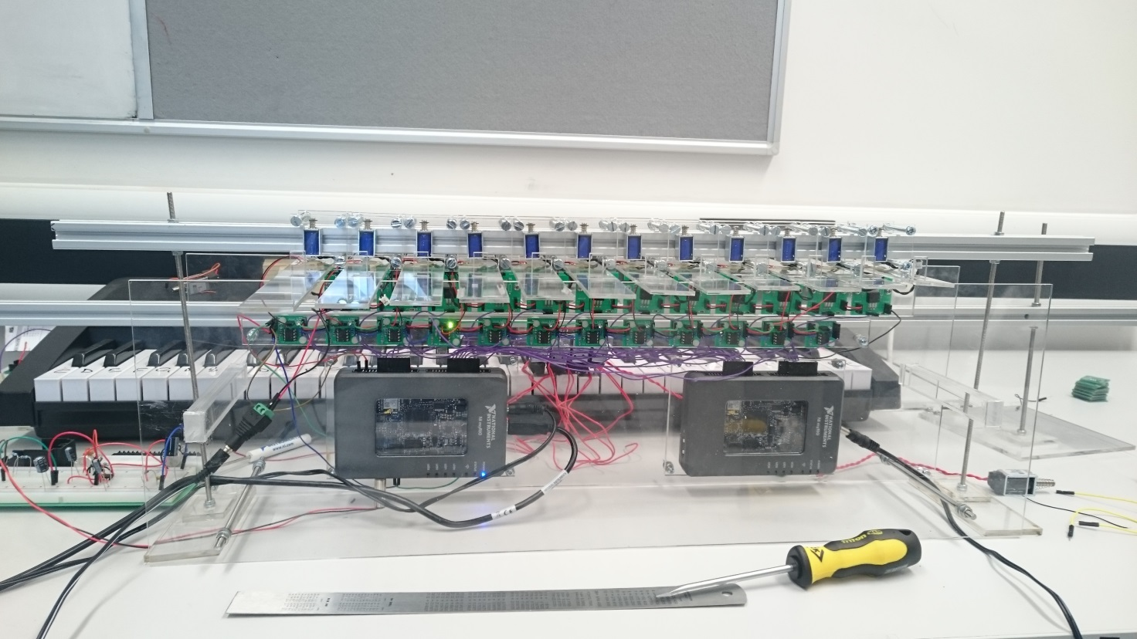

Figure 1.1: Xylophone instrument

## Solenoid choice and bracket design

The solenoids required for the xylophone have very few requirements. The piezos only require a slight tap to produce a signal. The keys are 30mm across so thee solenoid should be smaller than this. Due to the low quality requirements, the cheapest solenoids were chosen at £5 each. The dimensions are 10mm by 12mm and have a power of 10W rated at 5V and 2A So they are more than capable.

The specification of the bracket is that it needed to hold the solenoid onto the Bosch bar. Initially, a bracket was made by the workshop using a 3d printer the issue with this bracket was that it kept breaking mainly the socket holding the screw that held the solenoid in place would come loose (shown in Figure 1.2). A new bracket was designed which was made out of two clear Perspex plates which clamp the solenoids to the Bosch bar as can be seen in Figure 1.2. This design also fits better with the athletics of the xylophone as it displays the solenoid.

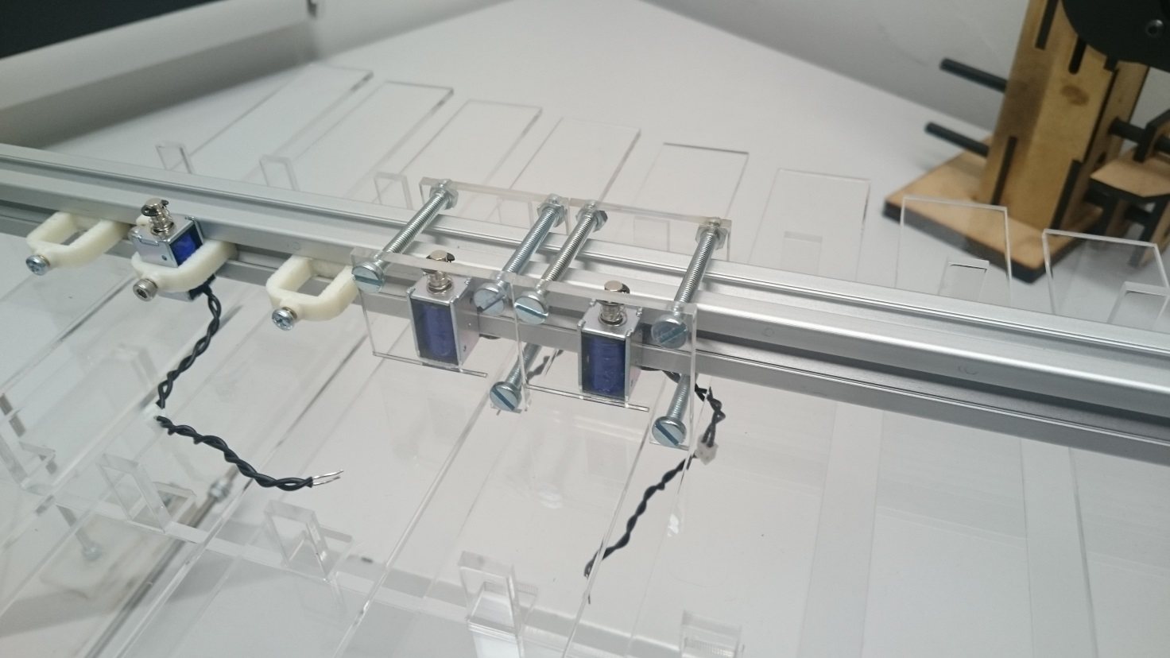

3d printed bracket

Socket that kept breaking

New bracket

Figure 1.2: 3D printed bracket and Perspex bracket

## Design of Bosch Bar Supports

The Bosch bar will be held using two threaded rods with a diameter of 4mm these rods will be held vertically using the same concept as used in the keyboard stands. The dimensions of the stands were adjusted so the stand could be attached to the xylophone. The dimensions for the bottom plate is 115x50mm and the smaller plate 40x30mm and it can be seen in Figure 1.3 (a). The bracket is attached to the xylophone using the connection shown in Figure 1.3(b).

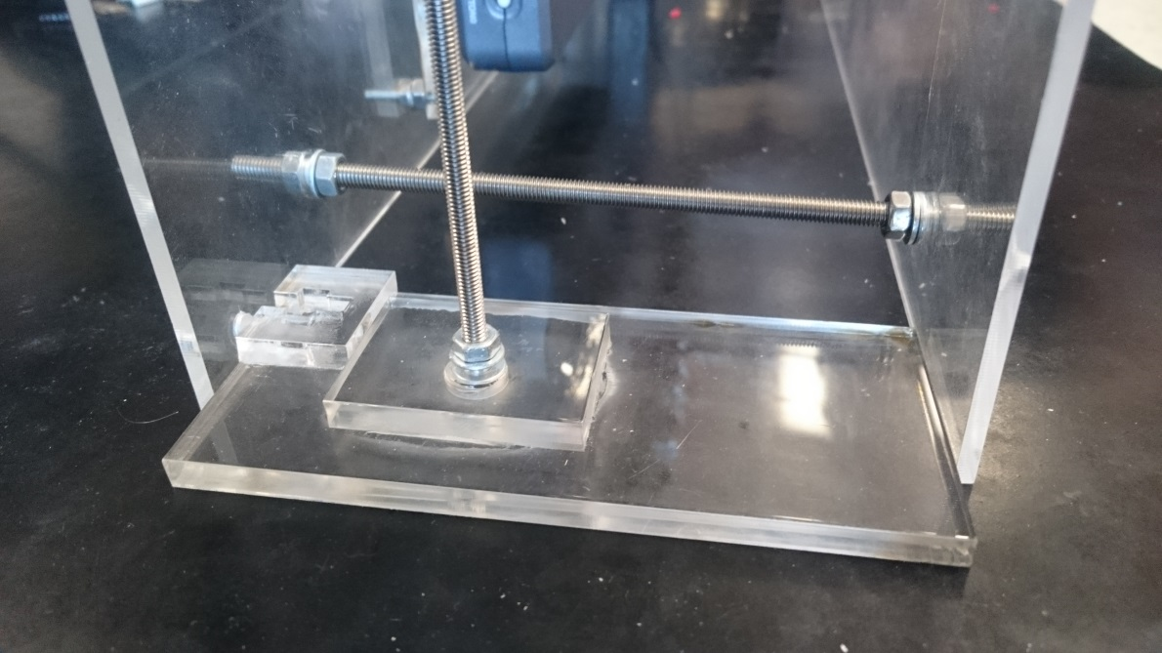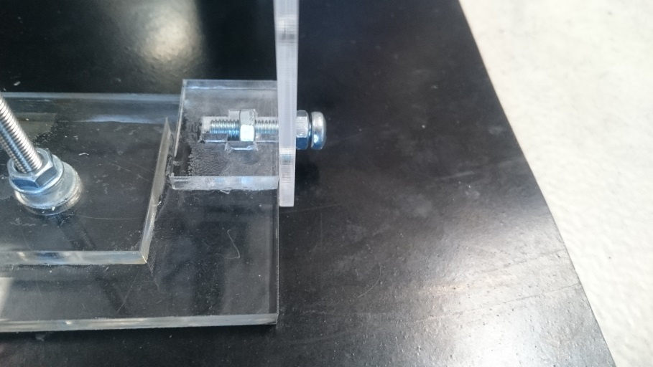

a

b

Perspex stand

Threaded rod

Fixing to connect the stand to the xylophone

xylophone

Figure 1.3: (a) shows the stand for the Bosch bar and (b) shows the connection of the stand to the xylophone

## Xylophone PCB circuit

As stated in the keyboard section the same transistor circuit is to be used for the xylophone circuit. The Vin=3.3V, Vbe=1.6, gain=4000 at when Ic=2A so the base resistor needed is R=(3.3-1.6)/(2/4000)=3.4kΩ. Using the E24 resistor series a 3.3kΩ resistor was selected.

## PCB Mounting Plate

To mount the PCB a separate plates were made one for all of the comparator circuits and one for all the solenoid switching circuits and one for each myRio these are so that each individual section can be dismounted easily for maintenance or transport. The designs are in appendix

**Subheading 1 (Bold, Normal)**

The Raspberry Pi has an inbuilt Bluetooth module capable of transmitting to other Bluetooth enabled devices.

**Subheading 2**

After researching WiFi as a transmission method the team found that it is much easier to implement than Bluetooth.

Equation is centred (Equation number) [Reference]:

(1) [53]

# References

[1] BBC, “BBC Radio 1 - Can a robot replace Ed Sheeran?,” BBC, 3 March 2017. [Online]. Available: <http://www.bbc.co.uk/programmes/p04sxvgw> [Accessed October 2017].

[2] L. Mather, “Glock o Bot,” YouTube, 13 June 2016. [Online]. Available: <https://www.youtube.com/watch?v=4toW8Tc9GPI> [Accessed October 2017].

[3] National Instruments, “Student Project Sponsorship - National Instruments United Kingdom,” National Instruments, 12 August 2017. [Online]. Available: <http://uk.ni.com/studentsponsorship> [Accessed November 2017].

[4] The editors of Encyclopedia Britannica. (2012). *Idiophone*. [Online] Available at: <https://www.britannica.com/art/idiophone> [Accessed November 2017].